|  |
| --- |
| IFMR RURAL FINANCE |
| Application Review |
|  |
| **IFMR Rural Finance** |
| **10/26/2016** |

|  |
| --- |
|  |

Contents

Process Diagram 3

1. Stage definition 4

2. Stage-role access 4

3. Application Review Queue 4

3.1 UI specification 4

3.2 Screenshot 5

3.3 Functional requirements 6

3.4 Upload 6

3.5 Download 6

3.6 Reports 6

4. Capturing Application data 7

4.1 UI requirements 7

4.2 Screenshots 41

4.3 Functional requirements 70

4.4 Uploads 70

4.5 Downloads 70

4.6 Reports 70

# Process Diagram



# Stage definition

|  |  |
| --- | --- |
| **Stage** | **Description** |
| Application Review Queue | The Hub Manager selects a profile from the pending for application review queue |
| Enter Remarks | The Hub Manager views the data presented, enters remarks and can either send back to any preceding stage for rework or submit to next stage (Field Appraisal) |

# Stage-role access

|  |  |
| --- | --- |
| **Stage** | **Applicable Role** |
| Application Review Queue | Hub Manager |
| Enter Remarks | Hub Manager |

# Application Review Queue

## UI specification

|  |  |  |  |  |
| --- | --- | --- | --- | --- |
| **Field name** | **Section** | **Data Type** | **Attribute** | **Population logic** |
| S. No. | Application Review Queue | Numeric |  |  |
| Applicant Name | Application Review Queue | Text | Sort/search | From application stage |
| Business Name | Application Review Queue | Alphanumeric | Sort/search | From application stage |
| URN No | Application Review Queue | Alphanumeric | Sort/search | From application stage |
| Area | Application Review Queue | Text | Sort/search | From application stage |
| City/Village/ Town | Application Review Queue | Text | Sort/search | From application stage |
| Pincode | Application Review Queue | Numeric |  | From application stage |

## Screenshot

* + 1. Search Page

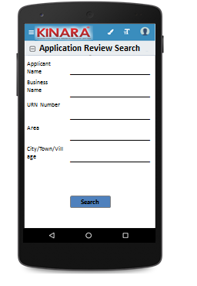

* + 1. Application Review Queue

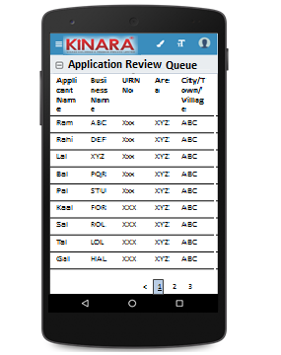

## Functional requirements

**Hub Manager** logs in

* The Hub Manager opens the process dash board, and clicks on Application Review Queue
* If the Hub Manager performs a search without selecting any parameter, then all cases with status ‘Pending for Application Review’ to be displayed in a tabular format.
* If the Hub Manager searches with ‘Applicant name’, ‘Business name’ or ‘URN no’, then all matching records that are ‘Pending for Application Review’ to be displayed in a tabular format.
* The Hub Manager can **search and sort** the profiles based on the following parameters: URN no, Applicant Name, Business Name, Area, City/Village/Town.
* The Hub Manager then selects a profile from the Application Review Queue. The queue table should have applicant name, business name, URN No, Area, City/Town/Village as column names.
* All the columns will have **sorting** facility.

## Upload

-NA-

## Download

-NA-

## Reports

-NA-

# Capturing Application data

## UI requirements

|  |  |  |  |  |  |  |  |  |
| --- | --- | --- | --- | --- | --- | --- | --- | --- |
| **Entity** | **Tab** | **Sub tab** | **Section** | **Fields** | **Field Value** | **Mandatory** | **Conditional Mandatory** | **Remarks** |
| **Application review** | Summary | Risk Score |  | Screening Score |  |  |  | From screening |
| Psychometric Score |  |  |  | From application |
| CB Check Report |  |  | Applicant |  |  |  | Calculated at application stage |
| Co-applicant |  |  |  | Calculated at application stage |
| Business |  |  |  | Calculated at application stage |
| **APPLICANT** | KYC Details |  |  | Aadhar No | Numeric | Yes |  | Auto-populated from application |
| Document Capture | Upload | Yes |  | Auto-populated from application |
| Pan Number | Alpha numeric | Yes |  | Auto-populated from application |
| Document Capture | Upload | Yes |  | Auto-populated from application |
| ID Type | Dropdown | Yes |  | Auto-populated from application |
| ID No | Alpha numeric |  | Yes | Auto-populated from application |
| Valid up to | Date |  |  | Auto-populated from application |
| Document Capture | Upload |  | Yes | Auto-populated from application |
| Applicant Details |  |  | Title* | Text |  |  | Auto-populated from application |
| Name* | Text | Yes |  | Auto-populated from application |
| Gender* | Text | Yes |  | Auto-populated from application |
| Date Of birth* | Text | Yes |  | Auto-populated from application |
| Age | Text |  |  | Auto-populated from application |
| Father's Name* | Text | Yes |  | Auto-populated from application |
| Educational Level* | Dropdown | Yes |  | Auto-populated from application |
| Religion* | Dropdown | Yes |  | Auto-populated from application |
| Mobile No* | Numeric | Yes |  | Auto-populated from application |
| Alternative Mobile No. | Numeric |  |  | Auto-populated from application |
| Whatsapp Mobile No. | Radio Buttons |  |  | Auto-populated from application |
| Email ID | Alphanumeric, special characters |  |  | Auto-populated from application |
| Preferred language of communication* | Dropdown | Yes |  | Auto-populated from application |
| Mother's Name | Text |  |  | Auto-populated from application |
| Marital Status | Dropdown | Yes |  | Auto-populated from application |
| Spouse Name | Text |  |  | Auto-populated from application |
| Relationship with Business | Dropdown | Yes |  | Auto-populated from application |
| Business Involvement* | Dropdown | Yes |  | Auto-populated from application |
| Have you ever been a proprietor or partner of any other company | Radio Buttons |  |  | Auto-populated from application |
| If yes, did the business close? | Radio Buttons |  |  | Auto-populated from application |
| Month/Year (of business closure) | Date |  |  | Auto-populated from application |
| Address Details |  |  | Type Of Address | Dropdown | Yes |  | Auto-populated from application |
| Care of | Text |  |  | Auto-populated from application |
| Building* | Alphanumeric, special characters | Yes |  | Auto-populated from application |
| Street | Alphanumeric, special characters |  |  | Auto-populated from application |
| Landmark | Alphanumeric, special characters |  |  | Auto-populated from application |
| Locality | Alphanumeric, special characters |  |  | Auto-populated from application |
| Pincode* | Numeric | Yes |  | Auto-populated from application |
| Village/Town/City* | Text | Yes |  | Auto-populated from application |
| District* | Text | Yes |  | Auto-populated from application |
| State* | Text | Yes |  | Auto-populated from application |
| Country* | Text | Yes |  | Auto-populated from application |
| Location | GPS coordinates | Yes |  | Auto-populated from application |
| Is the Communication Address same as the Aadhar Card address? | Radio Buttons | Yes |  | Auto-populated from application |
| Line 1 | Alpha numeric |  | Yes | Auto-populated from application |
| Line 2 | Alpha numeric |  |  | Auto-populated from application |
| Area | Alpha numeric |  |  | Auto-populated from application |
| Land Mark | Alpha numeric |  | Yes | Auto-populated from application |
| Pincode | Numeric |  | Yes | Auto-populated from application |
| City/Town/Village | Text |  | Yes | Auto-populated from application |
| District | Text |  | Yes | Auto-populated from application |
| State | Text |  | Yes | Auto-populated from application |
| Landline Number | Numeric |  |  | Auto-populated from application |
| Ownership | Dropdown | Yes |  | Auto-populated from application |
| How many years are you living in present Area? | Dropdown | Yes |  | Auto-populated from application |
| How many years are you living in current Address? | Dropdown | Yes |  | Auto-populated from application |
| Is the Communication Address same as Permanent Address? | Radio Buttons | Yes |  | Auto-populated from application |
| Family Member Details |  |  | Name | Text |  |  | Auto-populated from application |
| Relationship with applicant | Dropdown |  |  | Auto-populated from application |
| Profession | Dropdown |  |  | Auto-populated from application |
| Salary | Numeric |  |  | Auto-populated from application |
| Education fee (annual) | Numeric |  |  | Auto-populated from application |
| Is a Co-applicant? | Radio Buttons |  |  | Auto-populated from application |
| Household Financials |  |  | Other Income Source | Dropdown |  |  | Auto-populated from application |
| Amount | Numeric |  |  | Auto-populated from application |
| Expense Type | Dropdown |  |  | Auto-populated from application |
| Amount | Numeric |  |  | Auto-populated from application |
| Monthly Education Expenses | Auto Calculated |  |  | Auto-populated from application |
| Family Exp. Based on Education expense | Auto Calculated |  |  | Auto-populated from application |
| Asset Type | Dropdown |  |  | Auto-populated from application |
| Vehicle make & model | Alphanumeric |  | Yes | Auto-populated from application |
| Registered Owner | Alpha |  | Yes | Auto-populated from application |
| Value of the asset | Numeric |  | Yes | Auto-populated from application |
| Liabilities |  |  | Debt Source | Dropdown |  |  | Auto-populated from application |
| Creditor's Name | Alphanumeric |  |  | Auto-populated from application |
| Loan Amount | Numeric |  |  | Auto-populated from application |
| Loan Outstanding | Numeric |  |  | Auto-populated from application |
| Loan term | Alphanumeric |  |  | Auto-populated from application |
| Monthly Instalment | Numeric |  |  | Auto-populated from application |
| No. Of instalment Paid | Numeric |  |  | Auto-populated from application |
| Purpose | Dropdown |  |  | Auto-populated from application |
| Bank Statement Details |  |  | IFSC Code | Numeric |  |  | Auto-populated from application |
| Bank Name | Alphanumeric | Yes |  |  |
| Branch Name | Text |  |  | Auto-populated from application |
| A/C name | Alphanumeric | Yes |  | Auto-populated from application |
| A/C type | Text | Yes |  | Auto-populated from application |
| A/C no | Numeric | Yes |  | Auto-populated from application |
| Banking since | Date |  |  | Auto-populated from application |
| Net banking available | Radio Buttons | Yes |  | Auto-populated from application |
| Sanctioned Amount | Numeric |  | Yes | Auto-populated from application |
| Start Month | Date | Yes |  | Auto-populated from application |
| Total Deposits* | Numeric | Yes |  | Auto-populated from application |
| Total Withdrawals* | Numeric | Yes |  | Auto-populated from application |
| Balance as on 15th* | Numeric | Yes |  | Auto-populated from application |
| No of cheques bounced* | Numeric | Yes |  | Auto-populated from application |
| No of EMI cheques bounced* | Numeric | Yes |  | Auto-populated from application |
| References |  |  | Reference Type | Dropdown | Yes |  | Auto-populated from application |
| Full Name | Alphanumeric |  |  | Auto-populated from application |
| Mobile No | Numeric |  |  | Auto-populated from application |
| Occupation | Dropdown |  |  | Auto-populated from application |
| Self-reported Income | Numeric |  |  | Auto-populated from application |
| CO-APPLICANT | KYC Details |  |  | Aadhar No | Numeric | Yes |  | Auto-populated from application |
| Document Capture | Upload | Yes |  | Auto-populated from application |
| Pan Number | Alpha numeric | Yes |  | Auto-populated from application |
| Document Capture | Upload | Yes |  | Auto-populated from application |
| ID Type | Dropdown |  |  | Auto-populated from application |
| ID No | Alpha numeric |  | Yes | Auto-populated from application |
| Valid up to | Date |  |  | Auto-populated from application |
| Document Capture | Upload |  | Yes | Auto-populated from application |
| Co-Applicant Details |  |  | Title* | Text | Yes |  | Auto-populated from application |
| Name* | Text | Yes |  | Auto-populated from application |
| Gender* | Text | Yes |  | Auto-populated from application |
| Date Of birth* | Date | Yes |  | Auto-populated from application |
| Age | Numeric |  |  | Auto-populated from application |
| Father's Name* | Text | Yes |  | Auto-populated from application |
| Educational Level* | Dropdown | Yes |  | Auto-populated from application |
| Religion* | Dropdown | Yes |  | Auto-populated from application |
| Mobile No* | Numeric | Yes |  | Auto-populated from application |
| Alternative Mobile No. | Numeric |  |  | Auto-populated from application |
| Whatsapp Mobile No. | Radio Buttons |  |  | Auto-populated from application |
| Email ID | Alphanumeric, special characters |  |  | Auto-populated from application |
| Preferred language of communication* | Dropdown | Yes |  | Auto-populated from application |
| Mother's Name | Text |  |  | Auto-populated from application |
| Marital Status | Dropdown | Yes |  | Auto-populated from application |
| Spouse Name | Text |  | Yes | Auto-populated from application |
| Relationship with Applicant | Text | Yes |  | Auto-populated from application |
| Relationship with Business | Dropdown | Yes |  | Auto-populated from application |
| Business Involvement* | Dropdown | Yes |  | Auto-populated from application |
| Have you ever been a proprietor or partner of any other company | Radio Buttons |  |  | Auto-populated from application |
| If yes, did the business close? | Radio Buttons |  |  | Auto-populated from application |
| Month/Year (of business closure) | Date |  |  | Auto-populated from application |
| Address Details |  |  | Type Of Address | Dropdown | Yes |  | Auto-populated from application |
| Care of | Text |  |  | Auto-populated from application |
| Building* | Alphanumeric, special characters | Yes |  | Auto-populated from application |
| Street | Alphanumeric, special characters |  |  | Auto-populated from application |
| Landmark | Alphanumeric, special characters |  |  | Auto-populated from application |
| Locality | Alphanumeric, special characters |  |  | Auto-populated from application |
| Pincode* | Numeric | Yes |  | Auto-populated from application |
| Village/Town/City* | Text | Yes |  | Auto-populated from application |
| District* | Text | Yes |  | Auto-populated from application |
| State* | Text | Yes |  | Auto-populated from application |
| Country* | Text | Yes |  | Auto-populated from application |
| Location | GPS coordinates |  |  | Auto-populated from application |
| Is the Communication Address same as the Aadhar Card address? | Radio Buttons | Yes |  | Auto-populated from application |
| Line 1 | Alpha numeric |  | Yes | Auto-populated from application |
| Line 2 | Alpha numeric |  |  | Auto-populated from application |
| Area | Alpha numeric |  |  | Auto-populated from application |
| Land Mark | Alpha numeric |  | Yes | Auto-populated from application |
| Pincode | Numeric |  | yes | Auto-populated from application |
| State | Auto populated |  | Yes | Auto-populated from application |
| District | Auto populated |  | Yes | Auto-populated from application |
| City/Town/Village | Auto populated |  | Yes | Auto-populated from application |
| Location (GPS) | GPS coordinates |  |  | Auto-populated from application |
| Landline Number | Numeric |  |  | Auto-populated from application |
| Ownership | Dropdown | Yes |  | Auto-populated from application |
| How many years are you living in present Area? | Dropdown | Yes |  | Auto-populated from application |
| How many years are you living in current Address? | Dropdown | Yes |  | Auto-populated from application |
| Is the Communication Address same as Permanent Address? | Radio Buttons | Yes |  | Auto-populated from application |
| Family Member Details |  |  | Name | Text |  |  | Auto-populated from application |
| Relationship with co-applicant | Text |  |  | Auto-populated from application |
| Profession | Text |  |  | Auto-populated from application |
| Salary | Numeric |  |  | Auto-populated from application |
| Education fee (annual) | Numeric |  |  | Auto-populated from application |
| Household Financials |  |  | Other Income Source | Dropdown |  |  | Auto-populated from application |
| Amount | Numeric |  |  | Auto-populated from application |
| Expense Type | Dropdown |  |  | Auto-populated from application |
| Amount | Numeric |  |  | Auto-populated from application |
| Monthly Education Expenses | Auto Calculated |  |  | Auto-populated from application |
| Family Exp. Based on Education expense | Auto Calculated |  |  | Auto-populated from application |
| Asset Type | Dropdown |  |  | Auto-populated from application |
| Vehicle make & model | Alphanumeric |  | Yes | Auto-populated from application |
| Registered Owner | Alpha |  | Yes | Auto-populated from application |
| Value of the asset | Numeric |  | Yes | Auto-populated from application |
| Bank Statement Details |  |  | IFSC Code | Numeric |  |  | Auto-populate from application |
| Bank Name | Alphanumeric | Yes |  | Auto-populate from application |
| Branch Name | Text |  |  | Auto-populate from application |
| A/C name | Alphanumeric | Yes |  | Auto-populate from application |
| A/C type | Text | Yes |  | Auto-populate from application |
| A/C no | Numeric | Yes |  | Auto-populate from application |
| Banking since | Date |  |  | Auto-populate from application |
| Net banking available | Radio Buttons | Yes |  | Auto-populate from application |
| Sanctioned Amount | Numeric |  | Yes | Auto-populate from application |
| Start Month | Date | Yes |  | Auto-populate from application |
| Total Deposits* | Numeric | Yes |  | Auto-populate from application |
| Total Withdrawals* | Numeric | Yes |  | Auto-populate from application |
| Balance as on 15th* | Numeric | Yes |  | Auto-populate from application |
| No of cheques bounced* | Numeric | Yes |  | Auto-populate from application |
| No of EMI cheques bounced* | Numeric | Yes |  | Auto-populate from application |
| GUARANTOR | KYC Details |  |  | Aadhar No | Numeric | Yes |  | Auto-populate from application |
| Document Capture | Upload | Yes |  | Auto-populate from application |
| Pan Number | Alpha numeric | Yes |  | Auto-populate from application |
| Document Capture | Upload | Yes |  | Auto-populate from application |
| ID Type | Dropdown |  |  | Auto-populate from application |
| ID No | Alpha numeric |  | Yes | Auto-populate from application |
| Valid Up to | Date |  |  | Auto-populate from application |
| Document Capture | Upload |  | Yes | Auto-populate from application |
| Guarantor Details |  |  | Title* | Text | Yes |  | Auto-populate from application |
| Name* | Text | Yes |  | Auto-populate from application |
| Gender* | Text | Yes |  | Auto-populate from application |
| Date Of birth* | Date | Yes |  | Auto-populate from application |
| Age | Numeric |  |  | Auto-populate from application |
| Father's Name* | Text | Yes |  | Auto-populate from application |
| Educational Level* | Dropdown | yes |  | Auto-populate from application |
| Religion* | Dropdown | Yes |  | Auto-populate from application |
| Mobile No* | Numeric | Yes |  | Auto-populate from application |
| Alternative Mobile No. | Numeric |  |  | Auto-populate from application |
| Whatsapp Mobile No. | Radio Buttons |  |  | Auto-populate from application |
| Email ID | Alphanumeric, special characters |  |  | Auto-populate from application |
| Preferred language of communication* | Dropdown | Yes |  | Auto-populate from application |
| Mother's Name | Text |  |  | Auto-populate from application |
| Marital Status | Dropdown | Yes |  | Auto-populate from application |
| Spouse Name | Text |  | Yes | Auto-populate from application |
| Relationship with Applicant | Dropdown | Yes |  | Auto-populate from application |
| Business Involvement* | Dropdown | Yes |  | Auto-populate from application |
| Have you ever been a proprietor or partner of any other company | Radio Buttons |  |  | Auto-populate from application |
| If yes, did the business close? | Radio Buttons |  |  | Auto-populate from application |
| Month/Year (of business closure) | Date |  |  | Auto-populate from application |
| Address Details |  |  | Type Of Address | Dropdown | Yes |  | Auto-populate from application |
| Care of | Text |  |  | Auto-populate from application |
| Building* | Alphanumeric, special character | Yes |  | Auto-populate from application |
| Street | Alphanumeric, special character |  |  | Auto-populate from application |
| Landmark | Alphanumeric, special character |  |  | Auto-populate from application |
| Locality | Alphanumeric, special character |  |  | Auto-populate from application |
| Pincode* | Numeric | Yes |  | Auto-populate from application |
| Village/Town/City* | Text | Yes |  | Auto-populate from application |
| District* | Text | Yes |  | Auto-populate from application |
| State* | Text | Yes |  | Auto-populate from application |
| Country* | Text | Yes |  | Auto-populate from application |
| Is the Communication Address same as the Aadhar Card address? | Radio Buttons | Yes |  | Auto-populate from application |
| Line 1 | Alpha numeric |  | Yes | Auto-populate from application |
| Line 2 | Alpha numeric |  |  | Auto-populate from application |
| Area | Alpha numeric |  |  | Auto-populate from application |
| Land Mark | Alpha numeric |  | Yes | Auto-populate from application |
| Pincode | Numeric |  | Yes | Auto-populate from application |
| City/Town/ Village | Auto populated |  | Yes | Auto-populate from application |
| District | Auto populated |  | Yes | Auto-populate from application |
| State | Auto populated |  | Yes | Auto-populate from application |
| Location (GPS) | GPS coordinates |  |  | Auto-populate from application |
| Landline Number | Numeric |  |  | Auto-populate from application |
| Ownership | Dropdown | Yes |  | Auto-populate from application |
| How many years are you living in present Area? | Dropdown | Yes |  | Auto-populate from application |
| How many years are you living in current Address? | Dropdown | Yes |  | Auto-populate from application |
| Is the Communication Address same as Permanent Address? | Radio Buttons | Yes |  | Auto-populate from application |
| BUSINESS | Business Detail |  |  | Referred by | Dropdown | Yes |  | Auto-populate from application |
| Referred Name | Text |  | Yes | Auto-populate from application |
| Business Name | Text | Yes |  | Auto-populate from application |
| Business type | Dropdown | Yes |  | Auto-populate from application |
| Business Activity | Radio Buttons | Yes |  | Auto-populate from application |
| Add Business Type |  |  |  | Auto-populate from application |
| Business Sector | Text | Yes |  | Auto-populate from application |
| Business Sub sector | Text | Yes |  | Auto-populate from application |
| ITR available? | Radio Buttons |  |  | Auto-populate from application |
| Business Operating since | Date |  |  | Auto-populate from application |
| Is the Business Registered? | Radio Buttons | Yes |  | Auto-populate from application |
| Business Registration Type | Dropdown |  | Yes | Auto-populate from application |
| Business Registration proof no | Alpha numeric |  | Yes | Auto-populate from application |
| Business Registration Date | Date |  | Yes | Auto-populate from application |
| Valid Up to | Date |  | Yes | Auto-populate from application |
| Document Capture | Upload |  | Yes | Auto-populate from application |
| Constitution | Dropdown |  |  | Auto-populate from application |
| If partnership, how many total partners | Dropdown |  | Yes | Auto-populate from application |
| Has anyone else been a partner of your present business | Radio Buttons |  |  | Auto-populate from application |
| If yes, when was that partnership dissolved? | Date |  | Dissolution Agreement required | Auto-populate from application |
| Address Details |  |  | Line 1 | Alpha numeric | Yes |  | Auto-populate from application |
| Line 2 | Alpha numeric |  |  | Auto-populate from application |
| Pin Code | Numeric | Yes |  | Auto-populate from application |
| City/Village | Auto populated | Yes |  | Auto-populate from application |
| State | Auto populated | Yes |  | Auto-populate from application |
| District | Auto populated | Yes |  | Auto-populate from application |
| Land Mark | Text | Yes |  | Auto-populate from application |
| Location (GPS) | GPS coordinates |  |  | Auto-populate from application |
| Landline Phone | Numeric | Yes |  | Auto-populate from application |
| Ownership (Owned/Rent/Lease) | Dropdown | Yes |  | Auto-populate from application |
| How many years business in present Area? | Dropdown | Yes |  | Auto-populate from application |
| How many years business in current address? | Dropdown | Yes |  | Auto-populate from application |
| Employee Detail |  |  | No of Male Employees | Numeric |  |  | Auto-populate from application |
| No of Female Employees | Numeric |  |  | Auto-populate from application |
| Average Monthly Salary | Numeric |  |  | Auto-populate from application |
| Buyer Detail |  |  | Buyer Name | Alpha numeric |  | Yes | Auto-populate from application |
| Customer Since | Dropdown |  | Yes | Auto-populate from application |
| Sector | Dropdown |  | Yes | Auto-populate from application |
| Sub Sector | Dropdown |  | Yes | Auto-populate from application |
| Product | alpha numeric |  |  | Auto-populate from application |
| Payment terms (days) | numeric |  |  | Auto-populate from application |
| Payment date | Date |  |  | Auto-populate from application |
| Payment Frequency | Dropdown |  |  | Auto-populate from application |
| Receivables Outstanding / Customer Credit | numeric |  |  | Auto-populate from application |
| Business Financials | Income | Through Sales | Buyer Name | Dropdown |  |  | Auto-populate from application |
| Income type | Radio Buttons |  |  | Auto-populate from application |
| Amount | Numeric |  |  | Auto-populate from application |
| Date | Date |  |  |  |
| Other Business Income | Income Source | Dropdown |  |  | Auto-populate from application |
| Amount | Numeric |  |  | Auto-populate from application |
| Date | Date |  |  |  |
| Expenses | Raw material expense | Vendor Name | Alphanumeric |  | Yes | Auto-populate from application |
| Type | Radio Buttons |  |  | Auto-populate from application |
| Amount | Numeric |  |  | Auto-populate from application |
| Date | Date |  |  |  |
| Salary and Wages | Owner's Salary | Numeric |  |  | Auto-populate from application |
| Co- Owner's Salary | Numeric |  |  | Auto-populate from application |
| Employee's Salary | Numeric |  |  | Auto-populate from application |
| Fixed Obligations | Payment of Debts | Numeric |  |  | Auto-populate from application |
| Savings/Committee /Chits | Numeric |  |  | Auto-populate from application |
| Insurance Premium amount | Numeric |  |  | Auto-populate from application |
| Other Expenses | Rent | Numeric |  |  | Auto-populate from application |
| Sub-Contractor Payment | Numeric |  |  | Auto-populate from application |
| Tools & Consumables | Numeric |  |  | Auto-populate from application |
| Electricity Charges | Numeric |  |  | Auto-populate from application |
| Transportation Costs | Numeric |  |  | Auto-populate from application |
| Repair and Maintenance | Numeric |  |  | Auto-populate from application |
| General Admin | Numeric |  |  | Auto-populate from application |
| Assets | Current Assets | Cash At Bank | Numeric |  |  | Auto-populate from application |
| Inventory | Raw Material | Numeric |  |  | Auto-populate from application |
| WIP | Numeric |  |  | Auto-populate from application |
| Finished Goods | Numeric |  |  | Auto-populate from application |
| Machinery | Machine Description | Alphanumeric |  | Yes | Auto-populate from application |
| Manufacturer Name | Alphanumeric |  |  | Auto-populate from application |
| Machine Type | Dropdown |  |  | Auto-populate from application |
| Machine Model | Alphanumeric |  |  | Auto-populate from application |
| Serial Number | Alphanumeric |  |  | Auto-populate from application |
| Purchase Price | Numeric |  |  | Auto-populate from application |
| Machine Purchased Year | Numeric |  |  | Auto-populate from application |
| Present Value | Numeric |  |  | Auto-populate from application |
| Is the Machine New? | Radio Buttons |  |  | Auto-populate from application |
| Funding Source | Dropdown |  |  | Auto-populate from application |
| Is the Machine Hypothecated? | Radio Buttons |  |  | Auto-populate from application |
| Machine Permanently fixed to building? | Radio Buttons |  |  | Auto-populate from application |
| Machine Bills | Upload |  | Yes | Auto-populate from application |
| Other Fixed assets | Asset Type | Dropdown |  |  | Auto-populate from application |
| Vehicle Make & Model (if asset type is vehicle) | Alphanumeric |  | Yes | Auto-populate from application |
| Value of Asset | Numeric |  |  | Auto-populate from application |
| Company Liabilities |  | Debt Source | Dropdown |  |  | Auto-populate from application |
| Creditor's Name | Alphanumeric |  |  | Auto-populate from application |
| Loan Amount | Numeric |  |  | Auto-populate from application |
| Loan Outstanding | Numeric |  |  | Auto-populate from application |
| Loan term | Alphanumeric |  |  | Auto-populate from application |
| Monthly Instalment | Numeric |  |  | Auto-populate from application |
| No. Of instalment Paid | Numeric |  |  | Auto-populate from application |
| Purpose | Dropdown |  |  | Auto-populate from application |
| Supplier’s Name | Alphanumeric |  |  | Auto-populate from application |
| Type | Dropdown |  |  | Auto-populate from application |
| Payment terms (days) | Numeric |  |  | Auto-populate from application |
| Amount | Numeric |  |  | Auto-populate from application |
| Financial Summary |  | Sales | Numeric |  |  | Auto-populate from application |
| Purchases | Numeric |  |  | Auto-populate from application |
| Operating Expenses | Numeric |  |  | Auto-populate from application |
| Household Expenses | Numeric |  |  | Auto-populate from application |
| Fixed Obligations | Numeric |  |  | Auto-populate from application |
| Net Business Income | Numeric |  |  | Auto-populate from application |
| Bank Statement Details |  |  | IFSC Code | Numeric |  |  | Auto-populate from application |
| Bank Name | Alphanumeric | Yes |  | Auto-populate from application |
| Branch Name | Text |  |  | Auto-populate from application |
| A/C name | Alphanumeric | Yes |  | Auto-populate from application |
| A/C type | Text | Yes |  | Auto-populate from application |
| A/C no | Numeric | Yes |  | Auto-populate from application |
| Banking since | Date |  |  | Auto-populate from application |
| Net banking available | Radio Buttons | Yes |  | Auto-populate from application |
| Sanctioned Amount | Numeric |  | yes | Auto-populate from application |
| Start Month | Date | Yes |  | Auto-populate from application |
| Total Deposits* | Numeric |  |  | Auto-populate from application |
| Total Withdrawals* | Numeric |  |  | Auto-populate from application |
| Balance as on 15th* | Numeric |  |  | Auto-populate from application |
| No of cheques bounced* | Numeric |  |  | Auto-populate from application |
| No of EMI cheques bounced* | Numeric |  |  | Auto-populate from application |
| References |  |  | Reference type | Dropdown | Yes |  | Auto-populate from application |
| Business Name | Alpha numeric |  |  | Auto-populate from application |
| Full Name of POC | Alpha numeric |  |  | Auto-populate from application |
| Mobile No | Numeric |  |  | Auto-populate from application |
| Business Sector | Dropdown |  |  | Auto-populate from application |
| Business sub sector | Dropdown |  |  | Auto-populate from application |
| Self-reported Income | Numeric |  |  | Auto-populate from application |
| LOAN DETAILS | Loan Proposal |  |  | Purpose | Dropdown | Yes |  | Auto-populate from application |
| Sub-purpose | Dropdown | Yes |  | Auto-populate from application |
| Do you have assets available for hypothecation | Radio Buttons |  |  | Auto-populate from application |
| If yes, estimated value of assets | Numeric |  | Yes | Auto-populate from application |
| Loan Amount | Numeric | Yes |  | Auto-populate from application |
| Term | Alpha numeric | Yes |  | Auto-populate from application |
| EMI Requested | Numeric | Yes |  | Auto-populate from application |
| EMI Payment Date Requested | Date |  |  | Auto-populate from application |
| Frequency | Dropdown | Yes |  | Auto-populate from application |
| Estimated date of Completion | Date |  |  | Auto-populate from application |
| Product Type | Text |  |  | Auto-populate from application |
| Customer sign date | Date | Yes |  | Auto-populate from application |
| New Asset Details |  |  | Machine | Alphanumeric |  | Yes | Auto-populate from application |
| Purchase Price | Numeric |  |  | Auto-populate from application |
| Expected Income | Numeric |  |  | Auto-populate from application |
| Manufacturer Name | Alphanumeric |  |  | Auto-populate from application |
| Machine Type | Dropdown |  |  | Auto-populate from application |
| Machine Model | Alphanumeric |  |  | Auto-populate from application |
| Serial No | Alphanumeric |  |  | Auto-populate from application |
| Expected purchase date | Date |  |  | Auto-populate from application |
| Machine Permanently fixed to building | Radio Buttons |  |  | Auto-populate from application |
| Hypothecated to Kinara | Dropdown |  |  | Auto-populate from application |
| Remarks |  |  |  | Remarks | Text box | Yes |  | Text box with 100 word limit |

**Details of Conditional Drop-downs**

1. **Business Type- Manufacturing**

|  |  |  |  |
| --- | --- | --- | --- |
| **Business Type** | **Business Activity** | **Business Sector** | **Business Sub Sector** |
| Manufacturing | Sales | Machine Components |  |
|  | Job Work |  | Agriculture Machinery |
|  | Job work & Sales |  | Satellite Equipment |
|  |  |  | Construction Equipment |
|  |  |  | Textile Machinery |
|  |  |  | Plastics Machinery |
|  |  |  | Chemical Processing Machinery |
|  |  |  | Paper & Paperboard making machinery |
|  |  |  | Food Manufacturing Machinery |
|  |  |  | Semi-conductor Machinery |
|  |  |  | Wire Cutting Machinery |
|  |  |  | Automation Machinery |
|  |  |  | Special Purpose Machinery |
|  |  |  | Aircraft/Defence Machines |
|  |  |  | Air conditioning/Heating |
|  |  |  | Elevator/Conveyor |
|  |  |  | Ovens/Furnaces |
|  |  |  | Office Machinery/Equipment |
|  |  |  | Pumps/Compressors/Valves |
|  |  |  | Power Equipment |
|  |  |  | General Purpose Machinery |
|  |  | Auto Components | 2-Wheelers |
|  |  |  | 4-Wheelers |
|  |  |  | Light Commercial Vehicles (utility trucks, pickups, etc) |
|  |  |  | Heavy Commercial Vehicles (Trucks/Lorries) |
|  |  |  | Passenger Vehicles (Vans, Buses) |
|  |  |  | Agriculture Vehicles (Tractors, Tillers) |
|  |  |  | Construction Vehicles (Bobcats, Loaders, Compactors, Drillers, Earth-moving, etc.) |
|  |  | Fabrication | Welding |
|  |  |  | Tool & Dies |
|  |  | Food Products | Dairy Products |
|  |  |  | Beverage |
|  |  |  | Oils |
|  |  |  | Grain Mills |
|  |  |  | Animal Feed |
|  |  |  | Processing/Preserving meat, fish, vegetables |
|  |  |  | Starch and Starch Products |
|  |  |  | Bakery Goods |
|  |  |  | Prepared Meals & Dishes |
|  |  | Leather | Tanning & Dyeing |
|  |  |  | Footwear |
|  |  |  | Luggage |
|  |  |  | Handbags |
|  |  | Wood | Sawmill |
|  |  |  | Wood Materials |
|  |  |  | Furniture |
|  |  |  | Household goods |
|  |  | Textiles | Spinning |
|  |  |  | Weaving |
|  |  |  | Bleaching |
|  |  |  | Dyeing |
|  |  |  | Dressing |
|  |  |  | Drying |
|  |  |  | Steaming |
|  |  |  | Shrinking |
|  |  |  | Printing |
|  |  | Apparel | Knitwear |
|  |  |  | Ethnic Wear |
|  |  |  | Western Wear |
|  |  |  | Underwear |
|  |  | Paper | Paper Recycling |
|  |  |  | Pulp making |
|  |  |  | Paper & Paper Rolls |
|  |  |  | Paper Products (cups, plates, toys, etc.) |
|  |  |  | Cardboard Paper Products |
|  |  |  | Corrugated Paper Products |
|  |  |  | Carbon Paper & Stationary Items |
|  |  | Printing | Packaging Printing |
|  |  |  | Publication Printing |
|  |  |  | Commercial Printing |
|  |  | Plastics | Plastic Recycling |
|  |  |  | Industrial Injection Moulding |
|  |  |  | Household Injection Moulding |
|  |  |  | Plastic Sheets and Films |
|  |  |  | Plastic Packaging (bags, boxes, cases, et) |
|  |  |  | Optical (eye glass frames, etc.) |
|  |  |  | Housewares |
|  |  |  | Pipes, Tubes and Fittings |
|  |  |  | Other Plastic Moulding & Extrusion |
|  |  |  | Plastic Furniture |
|  |  |  | Medical & Dental Appliances |
|  |  |  | Games & Toys |
|  |  |  | Writing (pens, desk stuff, etc.) |
|  |  |  | Sanitary (tubs, basins, etc.) |
|  |  |  | Travel Goods (luggage, bags, etc.) |
|  |  | Electronics | Electronic Components |
|  |  |  | Computer Components |
|  |  |  | Communication Equipment |
|  |  |  | Measuring & Testing Equipment |
|  |  |  | Optical Instruments |
|  |  |  | Electro-medical Equipment |
|  |  | Electrical | Control Panels |
|  |  |  | Motors |
|  |  |  | Generators |
|  |  |  | Batteries/Accumulators |
|  |  |  | Wiring and Wiring Devices |
|  |  |  | Lighting Equipment |
|  |  |  | Domestic Appliances |
|  |  | Medical Equipment | Medical Instruments |
|  |  |  | Dental Instruments |
|  |  |  | Hospital Equipment |
|  |  | Chemicals | Basic Chemicals |
|  |  |  | Fertilizers & Nitrogen Compounds |
|  |  |  | Plastics & Synthetic Rubber |
|  |  |  | Pesticides & Agro-chemicals |
|  |  |  | Paints, Varnishes, Coatings, Enamels & Lacquer |
|  |  |  | Soap & Detergents |
|  |  | Pharmaceuticals | Antibiotics, Serums, Vitamins |
|  |  |  | Ayurvedic Preparations |
|  |  |  | Homeopathic Preparations |
|  |  |  | Veterinary Preparations |
|  |  |  | Gauze, Bandages, Dressings |
|  |  | Rubber | Rubber Tyres and Tubes |
|  |  |  | Tyre and Tube Repair |
|  |  |  | Elastic Fabrics |
|  |  |  | Footwear |
|  |  |  | Glues & Adhesives |
|  |  |  | Rubber Sports Equipment |
|  |  |  | Boats & Rafts |
|  |  |  | Games & Toys & Balloons |
|  |  |  | Rubber Fittings (plates, sheets, rods, hoses) |

1. **Business Type-Trading**

|  |  |  |  |
| --- | --- | --- | --- |
| **Business Type** | **Business Line** | **Business Sector** | **Business Sub Sector** |
| Trading | Whole Sale | Automobiles | Auto Accessories |
| Retail | Automobiles | Auto Parts |
|  |  | Automobiles | Auto Tyres |
|  |  | Book Stores | Book Stores |
|  |  | Construction | Painting |
|  |  | Construction | Cement |
|  |  | Electricals | Electricals |
|  |  | Electricals | Lighting stores |
|  |  | Electronics | Camera stores |
|  |  | Electronics | Computers/tech shops |
|  |  | Electronics | Home appliances |
|  |  | Electronics | Kitchen appliances |
|  |  | Housewares | Kitchen Goods |
|  |  | Electronics | Mobile shops |
|  |  | Fashion | Baby products |
|  |  | Fashion | Clothing stores |
|  |  | Fashion | Luggage stores |
|  |  | Fashion | Shoe stores |
|  |  | Food & Beverage | Fruit/Veg Stands |
|  |  | Food & Beverage | Provision stores |
|  |  | Food & Beverage | Water Suppliers |
|  |  | Food & Beverage | Snack Shops |
|  |  | Food & Beverage | Sweet Shops |
|  |  | Food & Beverage | Ice-cream shops |
|  |  | Furniture | Wood Furniture |
|  |  | Furniture | Steel Furniture |
|  |  | Furniture | Plastic Furniture |
|  |  | Health & Beauty | Beauty Products |
|  |  | Health & Beauty | Eyewear stores |
|  |  | Health & Beauty | Health food stores |
|  |  | Health & Beauty | Jewellery stores |
|  |  | Health & Beauty | Pharmacy |
|  |  | Health & Beauty | Ayurvedic Medical |
|  |  | Health & Beauty | Homeopathic Medical |
|  |  | Health & Beauty | Sports equipment |
|  |  | Hobbies | Art and crafts store |
|  |  | Hobbies | Musical instruments |
|  |  | Hobbies | Pet goods store |
|  |  | Hobbies | Video stores |
|  |  | Housewares | Home Decor & Gifts |
|  |  | Housewares | Watch and clocks |
|  |  | Industrial | Industrial products |
|  |  | Industrial | Scrap Dealers |
|  |  | Stationary | Stationary |

1. **Business Type-Services**

|  |  |  |  |
| --- | --- | --- | --- |
| **Business Type** | **Business Line** | **Business Sector** | **Business Sub Sector** |
| Services | Retail (Business to Consumer) | Automobiles | Car Maintenance Services |
| Retail (Business to Business) | Automobiles | Tyre Retreading |
|  |  | Education | Education |
|  |  | Health & Beauty | Beauty/Hair |
|  |  | Health & Beauty | Diagnostics |
|  |  | Health & Beauty | Gym/Fitness |
|  |  | Health & Beauty | Salons |
|  |  | Home Care | Appliance Repair |
|  |  | Home Care | Carpentry |
|  |  | Home Care | Cleaning |
|  |  | Home Care | Construction |
|  |  | Home Care | Gardening |
|  |  | Home Care | Movers |
|  |  | Home Care | Painting |
|  |  | Home Care | Pest Control |
|  |  | Home Care | Plumbing |
|  |  | Industrial | Electro-plating |
|  |  | Industrial | Hydro-plating |
|  |  | Industrial | Heat Treatment |
|  |  | Industrial | Industrial Gases |
|  |  | Industrial | Waste & Water Management |
|  |  | Professional | Advertising |
|  |  | Professional | Dry Cleaning/Laundry |
|  |  | Professional | Event Planning |
|  |  | Professional | Financial |
|  |  | Professional | Legal |
|  |  | Professional | Medical |
|  |  | Professional | Opticians |
|  |  | Professional | Real Estate |
|  |  | Software & Tech | Graphic Design |
|  |  | Software & Tech | Software |
|  |  | Software & Tech | Telecommunication |
|  |  | Travel | Hotels |
|  |  | Travel | Restaurants |
|  |  | Travel | Tourism/Travel |
|  |  | Travel | Transport |

## Screenshots

UI layout: When Application Review is clicked the following screen will be displayed. This is also the first screen that will be displayed when a particular customer URN is clicked.

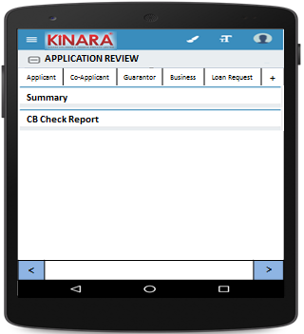

4.2(A) Summary

The initial Summary screen will look as below- with 1 sub-tab

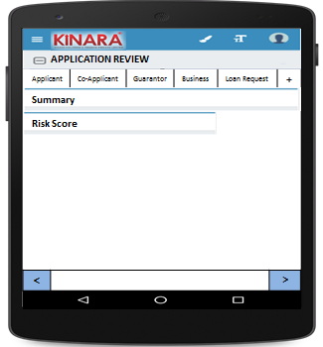

4.2(A1) Risk Score

|  |  |  |
| --- | --- | --- |
| Page 1 –Risk Score initial screen | Page 2- Screening score | Page 3 – Psychometric Score |

4.2(B) CB Check Report

CB report for each entity will be displayed under their respective tabs, as below.

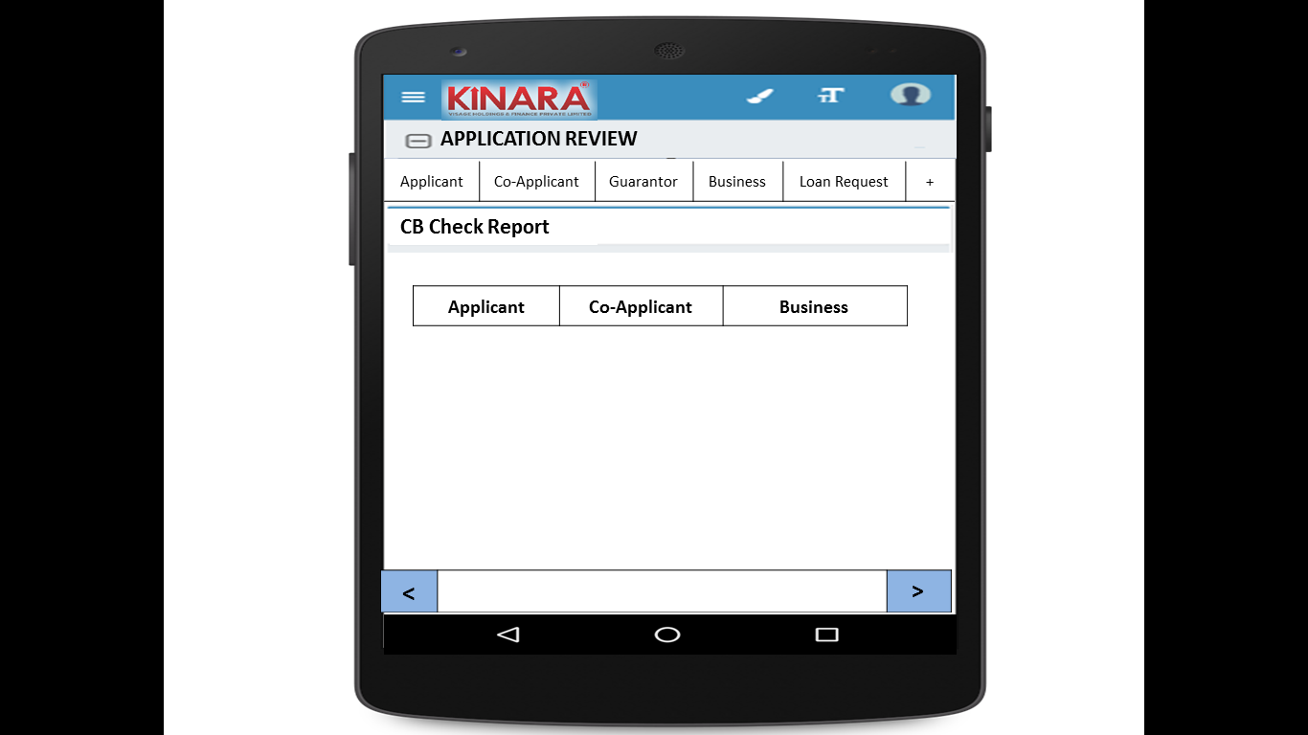

**4.2.1 Applicant**

Entity wise data display will start with Applicant

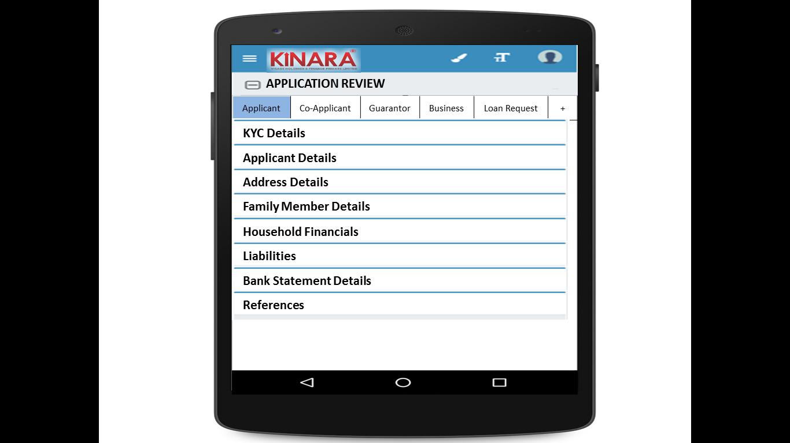

* + - 1. KYC Details:

All details will be auto-populated from application stage

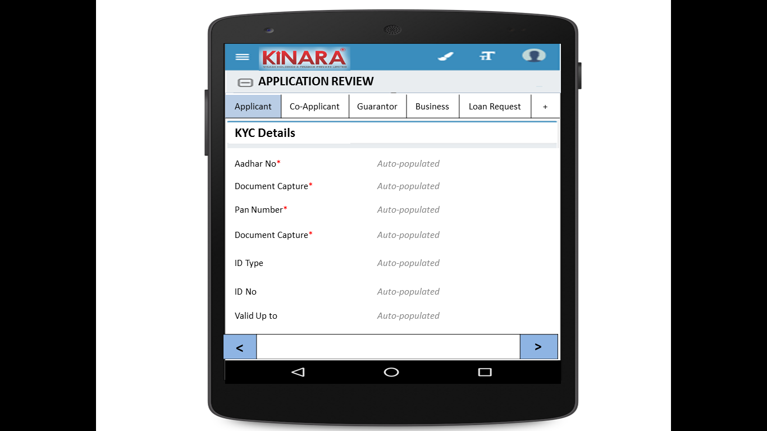

* + - 1. Applicant Details

All details will be auto-populated from application stage

|  |  |  |
| --- | --- | --- |
| Page 1 | Page 2 | Page 3 |

* + - 1. Address Details

All details will be auto-populated from application stage

|  |  |
| --- | --- |
| Page 1 | Page 2 |
| Page 3 | Page 4 |

* + - 1. Family Member Details

All details will be auto-populated from application stage

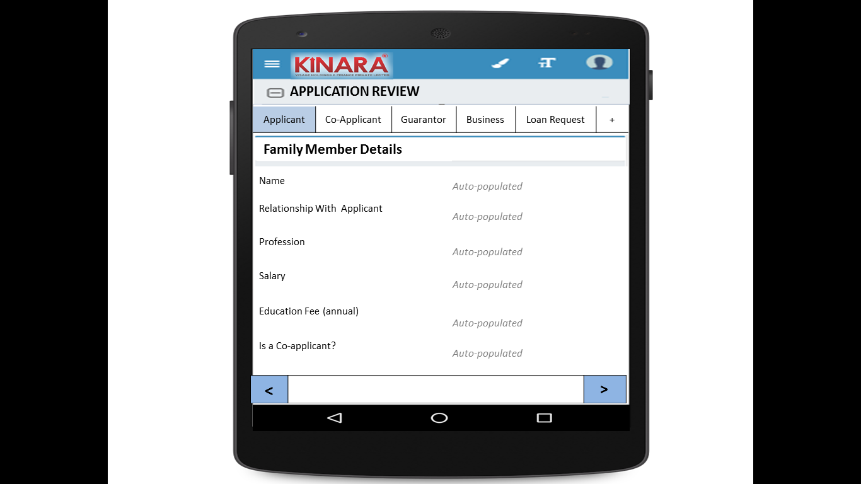

* + - 1. Household Financials

All details will be auto-populated from application stage

|  |  |
| --- | --- |
| Page 1 | Page 2 |

* + - 1. Liabilities

All details will be auto-populated from application stage

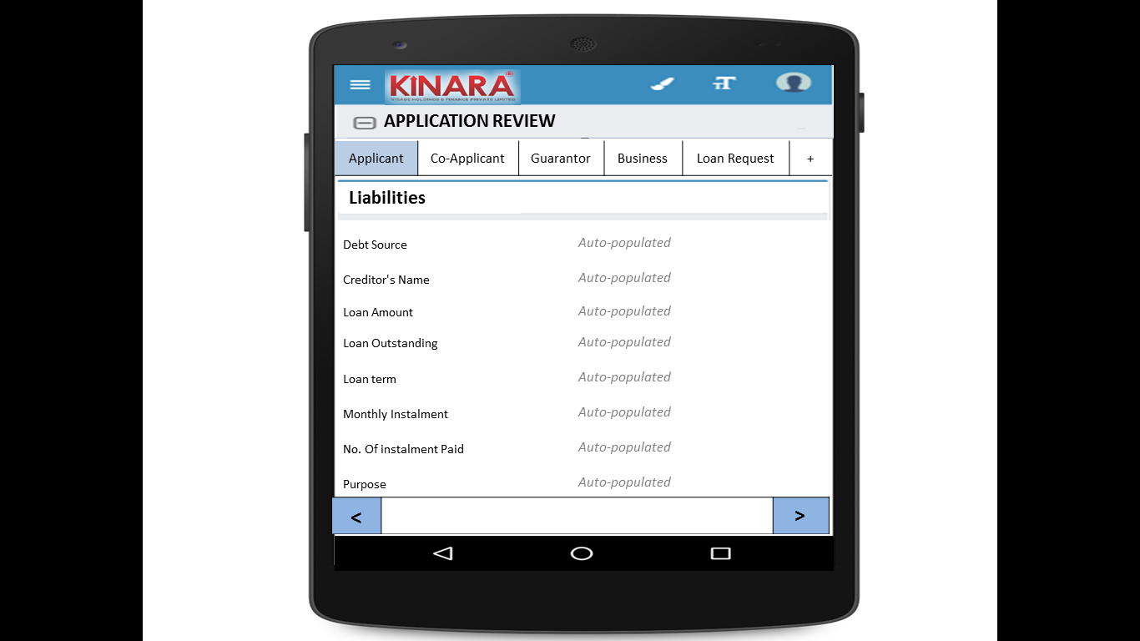

* + - 1. Bank Statement Details

All details will be auto-populated from application stage

|  |  |
| --- | --- |
| Page 1 | Page 2 |

* + - 1. References

All details will be auto-populated from application stage

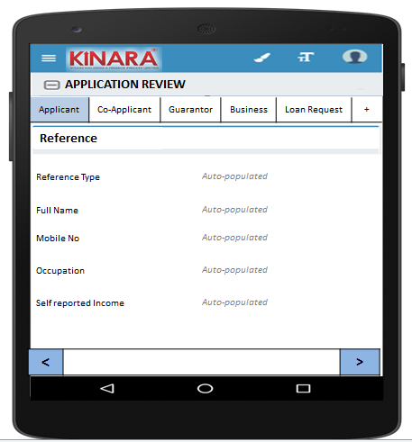

* + 1. **Co-applicant**

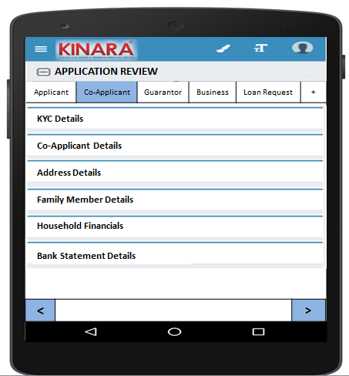

* + - 1. KYC Details

All details will be auto-populated from application stage

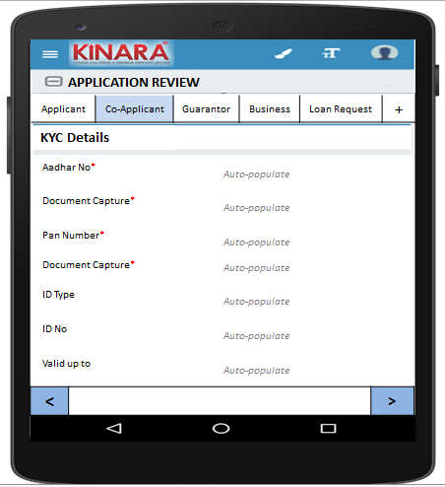

* + - 1. Co-applicant Details

All details will be auto-populated from application stage

|  |  |  |
| --- | --- | --- |
| Page 1 | Page 2 | Page 3 |

* + - 1. Address Details

All details will be auto-populated from application stage

|  |  |
| --- | --- |
| Page 1 | Page 2 |
| Page 3 | Page 4 |

* + - 1. Family Member Details

All details will be auto-populated from application stage

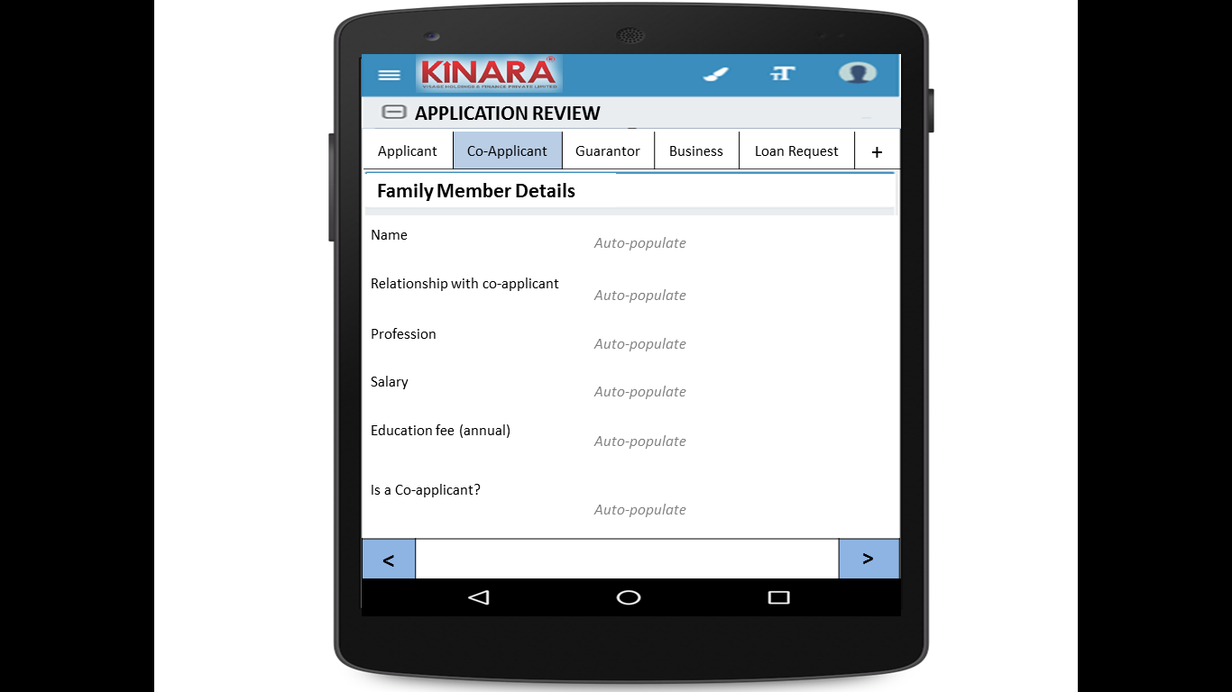

* + - 1. Household Financials  
         All details will be auto-populated from application stage

|  |  |
| --- | --- |
| Page 1 | Page 2 |

* + - 1. Bank Statement Details

All details will be auto-populated from application stage

|  |  |
| --- | --- |
| Page 1 | Page 2 |

* + 1. **Guarantor**

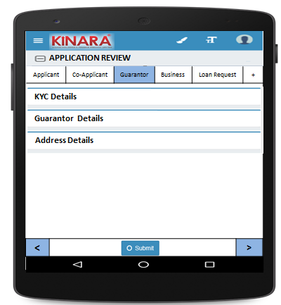

* + - 1. KYC Details

All details will be auto-populated from application stage

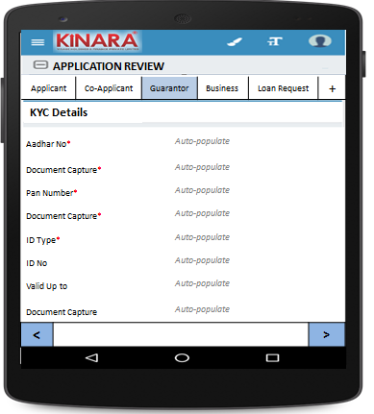

* + - 1. Guarantor Details

All details will be auto-populated from application stage

|  |  |  |
| --- | --- | --- |
| Page 1 | Page 2 | Page 3 |

* + - 1. Address Details

All details will be auto-populated from application stage

|  |  |
| --- | --- |
| Page 1 | Page 2 |
| Page 3 | Page 4 |

* + 1. **Business**

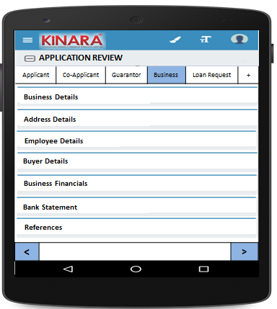

* + - 1. Business Details

All details will be auto-populated from application stage

|  |  |  |
| --- | --- | --- |
| Page 1 | Page 2 | Page 3 |

* + - 1. Address Details

All details will be auto-populated from application stage

|  |  |
| --- | --- |
| Page 1 | Page 2 |

* + - 1. Employee Details

All details will be auto-populated from application stage

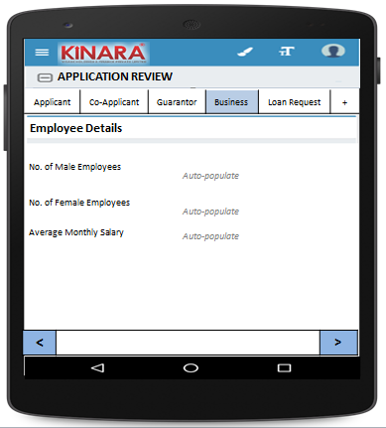

* + - 1. Buyer Details

All details will be auto-populated from application stage

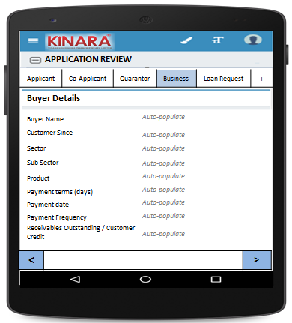

* + - 1. Business Financials

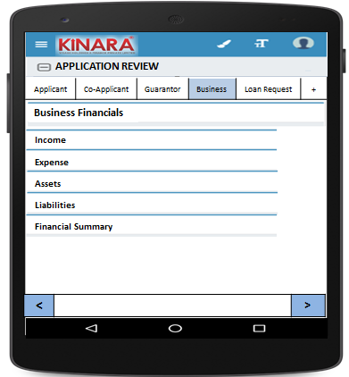

* + - * 1. Income

All details will be auto-populated from application stage

|  |  |
| --- | --- |
| Page 1 – Through Sales | Page 2 – Other Business Income |

* + - * 1. Expense

All details will be auto-populated from application stage

|  |  |
| --- | --- |
| Page 1- Raw material expense | Page 2 – Salary and wages |
| Page 3 – Fixed Obligations | Page 4 – Other Expenses |

* + - * 1. Assets

All details will be auto-populated from application stage

|  |  |
| --- | --- |
| Page 1 – Current Assets | Page 2 – Inventory |
| Page 3 – Machinery (1) | Page 4 – Machinery(2) |
| Page 5 – Other Assets | |

* + - * 1. Liabilities

All details will be auto-populated from application stage

|  |  |
| --- | --- |
| Page 1 – Fixed | Page 2 – Current |

* + - * 1. Financial Summary

All details will be auto-populated from application stage

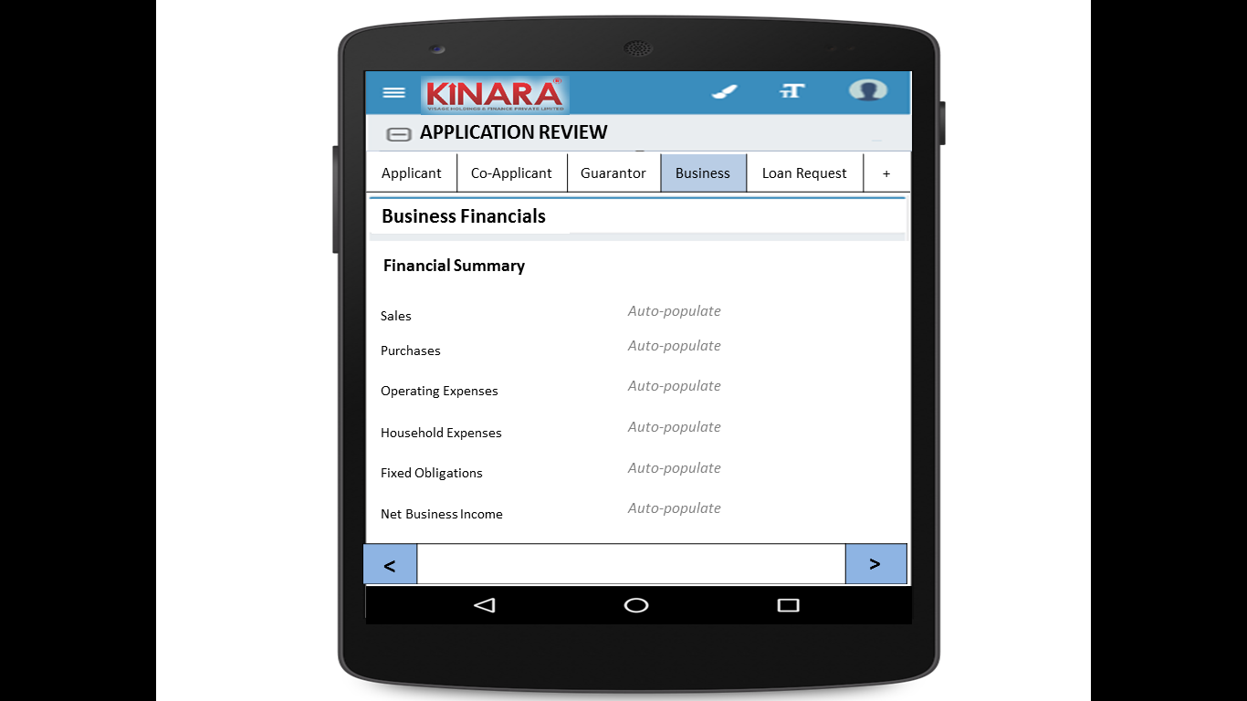

* + - 1. Bank Statement

All details will be auto-populated from application stage

|  |  |
| --- | --- |
| Page 1 | Page 2 |

* + - 1. References

All details will be auto-populated from application stage

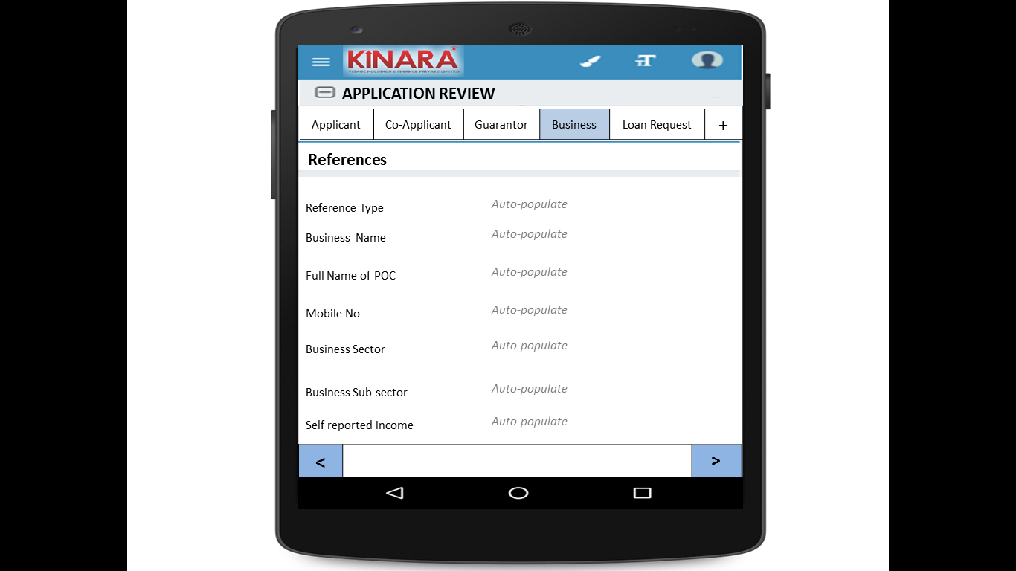

* + 1. **Loan Request**

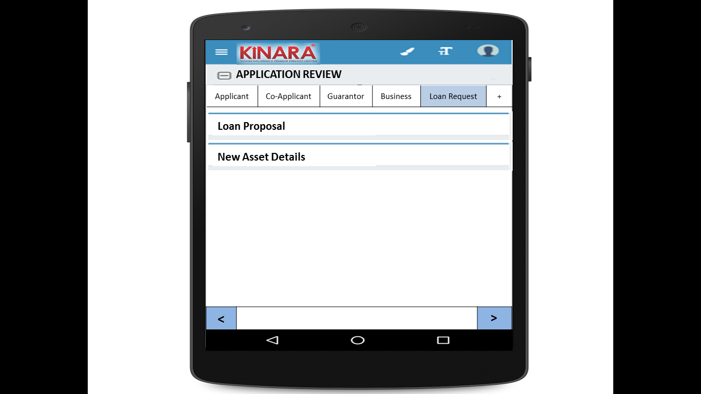

* + - 1. Loan Proposal

All details will be auto-populated from application stage

|  |  |
| --- | --- |
| Page 1 | Page 2 |

* + - 1. New Asset Details

All details will be auto-populated from application stage

|  |  |
| --- | --- |
| Page 1 | Page 2 |

* + 1. Remarks  
       All details will be auto-populated from application stage

|  |  |
| --- | --- |
| Page 1- Click + to add remarks | Page 2 – Enter remarks/send back/submit |

## Functional requirements

* 1. Once the profile is selected from the Application Review Queue, the Hub Manager can view all the data captured and scores tabulated up to the application stage.
  2. Hub Manager will view all data and enter remarks in the end
  3. In case of any deviations, the Hub Manager can send the loan back to any previous stage, or submit.
  4. On clicking ‘send back’ there should be option to choose which stage to send back to
  5. When submitted the loan will automatically move to pending for field appraisal queue

## Uploads

-NA-

## Downloads

-NA-

## Reports

-NA-